**Big Pattern 2026, Epilog**

On Sunday, January 18, 2026, 40 jugglers performed a *big lemniscate[1]* at the O’Keefe Middle School in Madison, as part of the 35th (minus one for covid) 47th annual Madfest. Lemniscate is a funny math word referring to a figure-8 shape (Figure 1), and the big lemniscate is a fun club-passing pattern involving a whole bunch of jugglers moving steadily through this shape while passing to others along the way. Counting jugglers and props, the version we did on January 18 was a trick involving 160 moving objects (40 jugglers and 120 clubs)! The video evidence

|  |
| --- |
|  |
| Figure . Lemniscate of Bernoulli. All points on the curve have the same product of distances to the two foci F1 and F2[2] (It’s also a familiar juggling shape!) |

confirms some drops (ha!), however in spite of those we got the pattern rolling and it was a blast. The big lemniscate is a group passing pattern where everyone moves and everyone passes to about ½ of the other jugglers. I’ve organized big patterns at Madfest for years, and also once at the IJA festival, and I have come to realize they can be a lot of fun for club passers while at the same time being a challenge to set up efficiently so that they are interesting and people can get right to the task. Nothing saps the enthusiasm of a group of jugglers like delays, confusion, and long discussions about where people are supposed to be and what they’re supposed to do to make a pattern happen. This note provides some details on how we set up the pattern to maximize fun. **something about big boring patterns vs big fun patterns**

Coming into the Madfest weekend, I wanted to be prepared for a variable number of jugglers, and had a sign-up sheet from the first night to encourage participation. It’s easier to sort out a pattern’s dimensions when you know the number of jugglers well in advance, but realistically it is pot luck in terms of who will show, so it’s good to be flexible and to be ready to adjust the size quickly. On Saturday night I settled on the number (40), hoping we’d have enough folks turning up for the 11am start, which we did! I needed some time to sort out the dimensions in advance. I had tried a 26-person version at the 2025 Madfest, but that did not go so well as I had the dimensions screwed up[3]. I workshopped a size-corrected 26-person version at the IJA festival in Indiana in summer 2025, which worked well, though the room size in that case limited the overall pattern size. In setting up for 2026, I wanted to be flexible with the final number, since we had room and a lot of potential passers, and so I needed a fast set up simpler than the geometric method I used previously.

**The Set Up.**

The long-side of the 40-person big lemniscate is about ** ft. This fills more than half a basketball court, which makes it far too big to eyeball approximate positions for the jugglers or to provide informal instructions on passing/moving rules. My solution is to mark out essential instructions on the gym floor in advance. Figure 2 shows some tools of the trade.

|  |
| --- |
|  |
| Figure . Tools you need to set up the big lemniscate: floor markers (various colors), tape measure, masking tape, playing cards (2 decks), rope. |

Every juggling pattern has its own special features. The big lemniscate gets its fun elements by having so many movers and by having a cool way to cross paths in center of the pattern. It may help to visualize the thin curve of Figure 1 as more of thick ribbon, with the ribbon’s two edges (teel and grey, Figure 3) defining paths of two groups of jugglers who move in opposite directions through the lemniscate.

|  |
| --- |
|  |
| Figure 3. Teel-colored path moves counter-clockwise (from above) on the inner edge of the right loop, and then clockwise on the outer edge of the left loop; the grey path goes in the opposite direction. 19 jugglers move along the teel path; another 19 move along the grey path. Small circles mark passing points. Red octagons are stop signs. |

The crossing rules at the center make this an especially fun pattern. That center is the first thing I mark on the gym floor. I mark a square with edges about 7 ½ ft (90 inches) and thus a diagonal about 10 ½ ft (Figure 4). By the way, the dimensions of this central square ought to be the same no matter how big you make big lemniscate (The juggling is easier for bigger numbers. Communication is easier for smaller numbers.) The pattern’s crossing and moving rules work only if you have the same **odd** number of jugglers moving along each of the two opposite paths. As noted, we had 19 movers on each path in the Madfest 2026 attempt, which corresponds to a 40-person pattern. It would be fun to go even bigger. I think the smallest you can do is 5 jugglers per path, which we found out at practice on **date**. After setting the central square with masking tape, I mark out the backbone of each lemniscate loop using a long rope, on which I’ve pre-set alternating-color tape marks every 5 ft (60 inches); see the dashed lines with open-circle ends in Figure 3.

|  |
| --- |
|  |
| Figure 4. Setting up the center. Stop signs mark each path’s entry into the crossing square. |

The alternating-color tape marks tell me where to place colored plastic floor markers indicating the passing points along each path. It’s worth to make a few comments about the marked rope before I explain the moving rule. I use enough rope for one full loop, setting up one side and then separately the second side. For each side of the pattern, the looping rope connects two adjacent corners of the central square. Importantly, the number of 5 ft segments of rope in one loop equals **; by having at least that many segments pre-set on the rope, you have the ability to adjust the size of each loop and thus overall size the pattern. Going for our 40-person pattern, I used **ft** of rope, which several Madfest volunteers helped to shape out in a lemniscate-loop by eye. (*note about the alternative geometric pedal construction*). To give a bit of necessary extra room near the central square, I start and end the rope loop 1-2 fit away from each connecting corner (see Figure 3). Next, my volunteers help me drop the colored plastic floor markers all the way around each loop (Figure 4). The use of four colors turns out to be convenient, with two-colors marking passing points on each of the opposing paths.

|  |
| --- |
|  |
| Figure 5. Floor markers for even (yellow/green) and odd (purple blue) passing beats on the grey path (yellow/purple) and the teel path (green/blue). |

For instance, I used green and blue markers on the teel path and yellow and purple markers on the grey path. Colors alternate on both paths in such a way that jugglers are at blue or purple spots on odd passing beats and they’re at green or yellow spots on even passing beats. Aside from the interesting crossing rule, the passing/moving rule entails simply passing at a passing point and then moving forward along your path to the next passing point. Your pass goes to whomever is in front of you on the opposite path; they will be facing you about 10 ft away. Moves follow passes, and so each passer ends up moving along their path so that they are side-by-side of the person they just passed with as they set up for their next pass to the next person along that path.

All that passing and moving along the loops is super fun, but the most exciting part of the pattern is crossing through the middle square. You’ll have noticed already in Figures 3 and 4 the presence of four stop-sign positions, which show up on a path as that path enters the square. The rule is simple: when you get land at a stop sign, you neither pass on the next passing beat nor move after that passing beat. In other words, when you arrive at a stop sign you stop, skip a passing beat, and stay put after that beat as two jugglers cross through from opposite corners. Then you take your turn, passing and moving fully across the diagonal to pick up the pattern on the other loop. To make up for skipped passes, each juggler at the passing point just prior to a stop sign needs someone to pass with, and we add two extra jugglers for that purpose. I call them jokers, considering the playing-card associations I describe shortly. Their centers of gravity don’t move; jokers are set up on either the top or bottom side of the central square. There’s one for the teel path and one for the grey path, and they end up swiveling back and forth on passing beats to pass alternatively to movers who are getting close to their respective stop signs. In summary, the moving jugglers pass at passing points, move along their respective paths one 5 ft segment after each pass. As they approach the stop sign they pass once to a joker, then they get to the stop, wait, and then proceed after skipping one beat.

I often use two decks of playing cards as a simple device to sort out where all the jugglers have to be at the beginning of big pattern. Cards from one deck go on the floor at respective starting spots; matching cards from second deck are in my possession when congregate to start the pattern, and we ritualistically have jugglers select cards at random to get their coordinates. The path structure of the big lemniscate is conducive to using cards of all four suits, running ace,

|  |  |
| --- | --- |
|  |  |
|  |  |
| Figure 6. First two passing beat…M=10 here, but could be some other even number…2M-1 movers per path; 4M-2 movers; 4M jugglers total considering the 2 jokers (small squares). | |

two, three, etc of a given suit along passing positions emanating from corners of the central square. I used hearts for the outer edge of the grey path (right loop) and clubs on the inner edge of the grey path (left loop); likewise, diamonds and spades live on the teel path. Figure 6 shows the first two passing beats. As it happens the odd number comes from the fact that there’s one more person occupying an outer edge than an inner edge on either loop. With our 40-person pattern, 10 jugglers are on each outer loop and 9 are on each inner loop. So the cards I need are ace to 10 of hearts, ace to ten of diamonds, ace to 9 of both clubs and spades. And since there are marks for odd and even passing beats, only half of the passing points receive cards as starting positions. To speed the set up, I tape the floor-bound cards to their respective plastic markers in advance (Figure 7 shows the simulation on my living room floor just before heading to the gym!)

**Let’s Juggle!**

Talk about walking it through etc; crossing guard; metronome

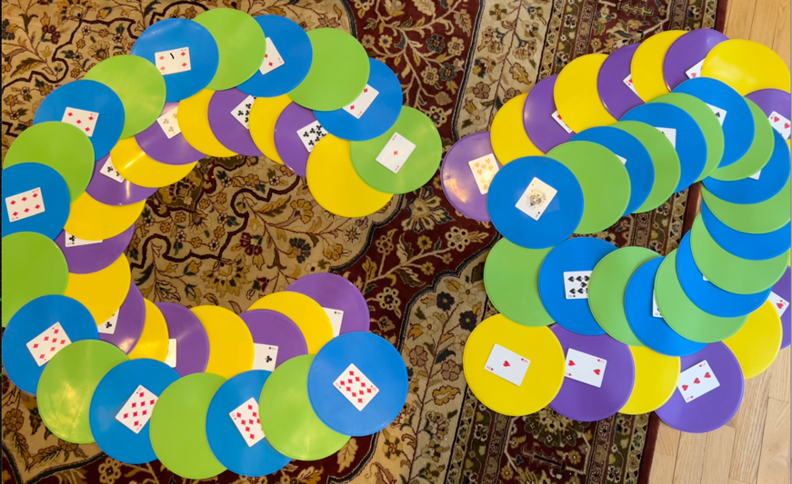

Figure 7. Living room simulation on the morning before the big pattern. The yellow/purple path is on the inner on the left and the outer on the right; the blue/green path is the opposite, being on the inner on the right and the outer on the left.

|  |
| --- |
|  |
| Figure 8. A drone’s view of the big lemniscate in action, showing center cross (blue tape) and of the two loops…. |

I also realized that with the comfortable 8-count passing rhythm (thanks Dan for calling the beats), we can get by with just two jokers, one for each path, who rotate about 180 degrees between alternating passes to their respective movers (Since the two jokers need to rotate, I consider that all jugglers have moving roles in the pattern.)

**Metronome and other tricks to make the pattern go**

**160 moving parts**

**?Nathan and a piano roll? What’s the cycle?**

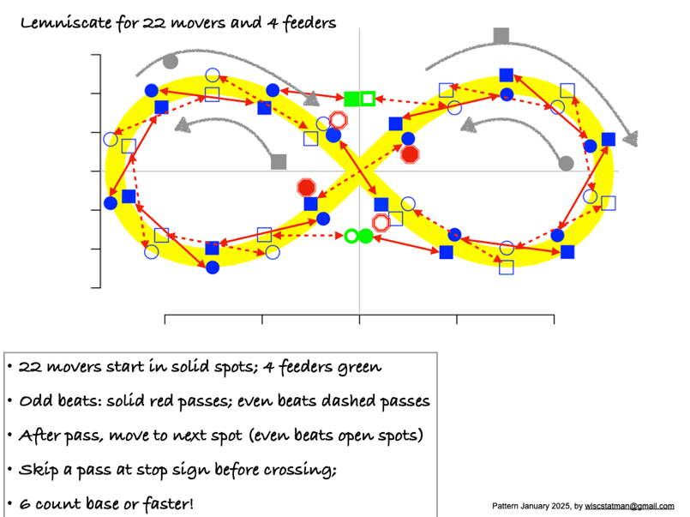

Figure . 22 person lemniscate, 2025 Madfest

Figure 1 summarizes the set up from 2025, involving 22 movers. The edges of that yellow band constitute paths of two groups of jugglers – circles and squares in this representation. The circles are moving counter-clockwise (from above) on the inside of the right-hand loop and they move clockwise on the outside of the left-hand loop. The squares are going on the opposite path and the opposite direction, moving clockwise on the outside of the right loop and counterclockwise on the inside of the left loop. The solid/open shading distinguishes odd beats and even beats; there are basically twice as many spots marked as jugglers, with jugglers moving after each pass into the next position along the respective path. Passes happen between jugglers on the opposite paths. The interesting business is in the crossing of paths, which we enable by having stop-sign positions being the only 4 positions in the pattern which when a juggler gets their the neither pass nor move on the next available beat; i.e. they wait one passing beat for the two jugglers crossing the other way to cross first. I’ll say more about the crossing business later, but first I share a few notes about the pattern set up. **

There’s nothing sacred about 22 movers.

1. Correctly pronounced with an accent on the second syllable and an ending that sounds a bit like ‘biscuit’
2. Figure by Kmhkmh - Own work, CC BY 4.0, <https://commons.wikimedia.org/w/index.php?curid=50728078>
3. I mixed up calculations in preparations for the first big pattern attempt (in Jan 2025), which meant everything was too small by a factor of about square root of 2. Jugglers were patient but the crossing lanes were very crowded!